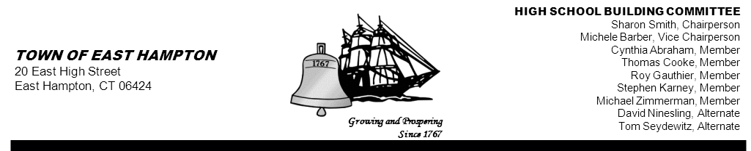

HIGH SCHOOL—ADDITION & RENOVATE-AS-NEW
HIGH SCHOOL BUILDING COMMITTEE MEETING
High School Library/Media Center
15 North Maple Street, East Hampton, CT 06424
Minutes
Thursday, May 30, 2013, 5:30 p.m.
PRESENT AT MEETING
Committee Members: Sharon Smith, Chairperson; Michele Barber, Vice Chairperson; Cynthia Abraham, Stephen Karney, Tom Seydewitz, and Roy Gauthier

Member(s) Absent: Michael Zimmerman, David Ninesling, Thomas Cooke, and Keith Klemonski, Parent Liaison

Also Present: Jim Giuliano, CREC Senior Project/Program Manager; Glenn Gollenberg, Principal In Charge SLAM;
Amy Samuelson, SLAM Associate; Michael MacDonald, NCARB Downes Construction; Michael Maniscalco, Town Manager, Susan Weinraub, Town Council member

1. Call to Order
The meeting was called to order by Sharon Smith, Chairperson at 5:32 p.m.

2. Public Remarks
Susan Weintraub Council member provided helpful information from “ Robert’s Rules of Order” regarding procedures for standard minutes.

3. Review and approve minutes from 05-16-13 and 05-21-13 Building Committee Meetings
The minutes from 05-21-13 was tabled until the next meeting due to incompletion.
MOTION: By Michele Barber, seconded by Stephen Karney
to approve the 05-16-13 minutes as amended.
Vote (5-0-1) Sharon Smith Abstained due to not being present at that meeting

4. Project Update (SLAM, CREC, Downes)
Jim Giuliano presented the following updates:
- Educational Specifications
- All meetings with the Board of Education in regards to Ed Specs have ended.
- All comments on Ed Specs have been updated.
- Ed Specs are being reviewed by Mark Winzler and John Fidler.
- An English teacher will also review the Ed Specs.
- BOE will meet on June 10th to accept the Ed Specs for the High School Renovate-As-New project

- EDO49 FORM— Grant Application and Executive Summary of Educational Specifications for a School Building Project has been completed and will need to be reviewed and signed.
- A certified copy of the resolution, which created the East Hampton High School Building Committee, is needed to satisfy the State of Connecticut. Mr. Giuliano will email Michael Maniscalco with information/checklist.
- A certified vote count will be needed once the referendum passes—Documentation of the Locally Authorize Funding, i.e., certified referendum language and vote count
- Eight Year Enrollment Projections—the NEASC report will serve as back-up to support projections
- Mr. Giuliano emailed Jeff Jylkka language for the resolutions that will need to be approved by the Town Council, once the referendum is passed. Mr. Giuliano noted that the resolutions will specify that the town will pay for the entire project and that bonds will be issued.
- Budget Report dated 05/30/13 was reviewed ( scroll to see attached to minutes)

Amy Samuelson and Glenn Gollenberg presented large poster boards with graphic images to display at the polling area. The committee was in agreement with using the poster boards.

Ms. Samuelson stated that SLAM received an email from the Middletown Press requesting digital files of the presentation from the informational meetings. Ms. Samuelson inquired if she could send them the files. The committee agreed that it is public information and that it would be permissible. It was also suggested that the presentation be put on the Town Website as well.

5. Referendum Update
Both informational meetings held for the public were minimally attended but the information was well received.

6. Approval of Invoices:
Jim Giuliano stated that each set of invoices will have a cover sheet going forward. Mr. Giuliano distributed copies of the invoices to the committee for review.

MOTION: By Stephen Karney, seconded by Tom Seydewitz
to approve the following two (2) Pre-Referendum Invoices submitted for approval on 5-30-2013:

Downes Construction Co.
Dated: May 29, 2013
DCC Job # 25-01-0275
Invoice #1
$16,200.00

The SLAM Collaborative, Inc.
Dated: May 07, 2013
Project #12068.00
Invoice #1009375
$5,807.54

Motion unanimously carried

(Scroll to see invoices attached)

A discussion took place regarding itemizing invoices on the budget report as well as attaching individual pages per contractor. Mr. Giuliano stated that he will provide that for the professional services (SLAM, Downes & CREC) going forward. Mr. Giuliano explained how Downes will be responsible for providing this information for the American Institute of Architects (AIA) payment documents e.g., G702, G703. Mr. Gollenberg suggested bringing in a sample from another project for the committee to review.

7. Chairs Update
Vice Chairperson Michele Barber reported that a ruling was received from attorneys regarding invoices. She also stated that it is too pre-mature to discuss before the referendum.

A discussion took place regarding archiving documents for the High School Building Project and the need to set up a schedule for presenting quarterly reports. It was determined that these items will be discussed at the Tri-Board meeting that will be scheduled after the referendum.

The next High School Building Committee meeting will be June 13.

8. Public Remarks
Ted Turner, Board of Finance member, inquired as to the purpose of the Tri-Board meeting. Susan Weintraub explained that the meeting is necessary to establish how the project will move forward for all boards.

9. Adjournment
MOTION: By Cynthia Abraham and seconded by Michele Barber
To adjourn the meeting at 6:15 p.m.
Motion unanimously carried

Respectfully submitted,

Priscilla Ulm
Recording Secretary

Attachments



